Revisions to tag errors:
01 32 16.00 20
- Changed HL4 to SCN on Line 10
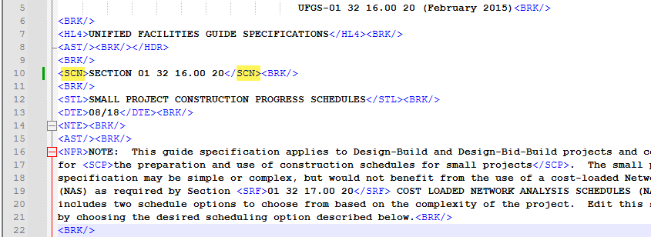

01 35 26
- Added </HL4> to line 663
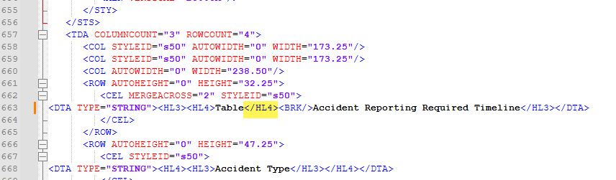

01 42 00
- Removed self-closing “/” from URL tags on lines 631 and 636
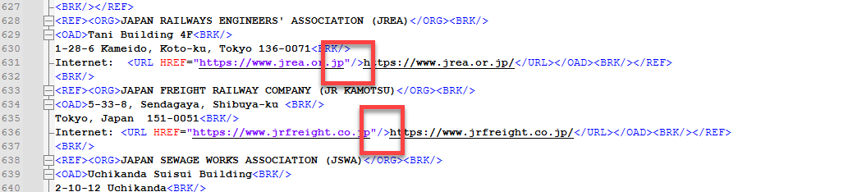

14 21 23
- Changed HL4 to SCN on Line 46
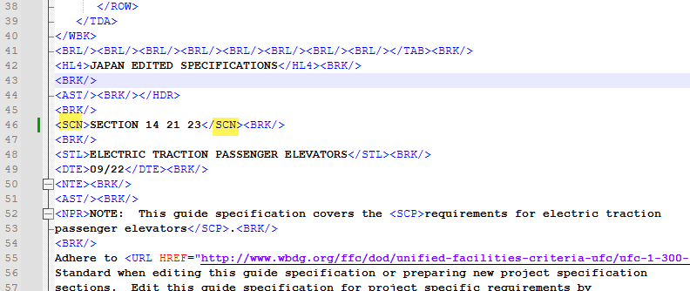

22 00 00
- Added closing tag </TAI> to line 1237
